Latest passport size photo
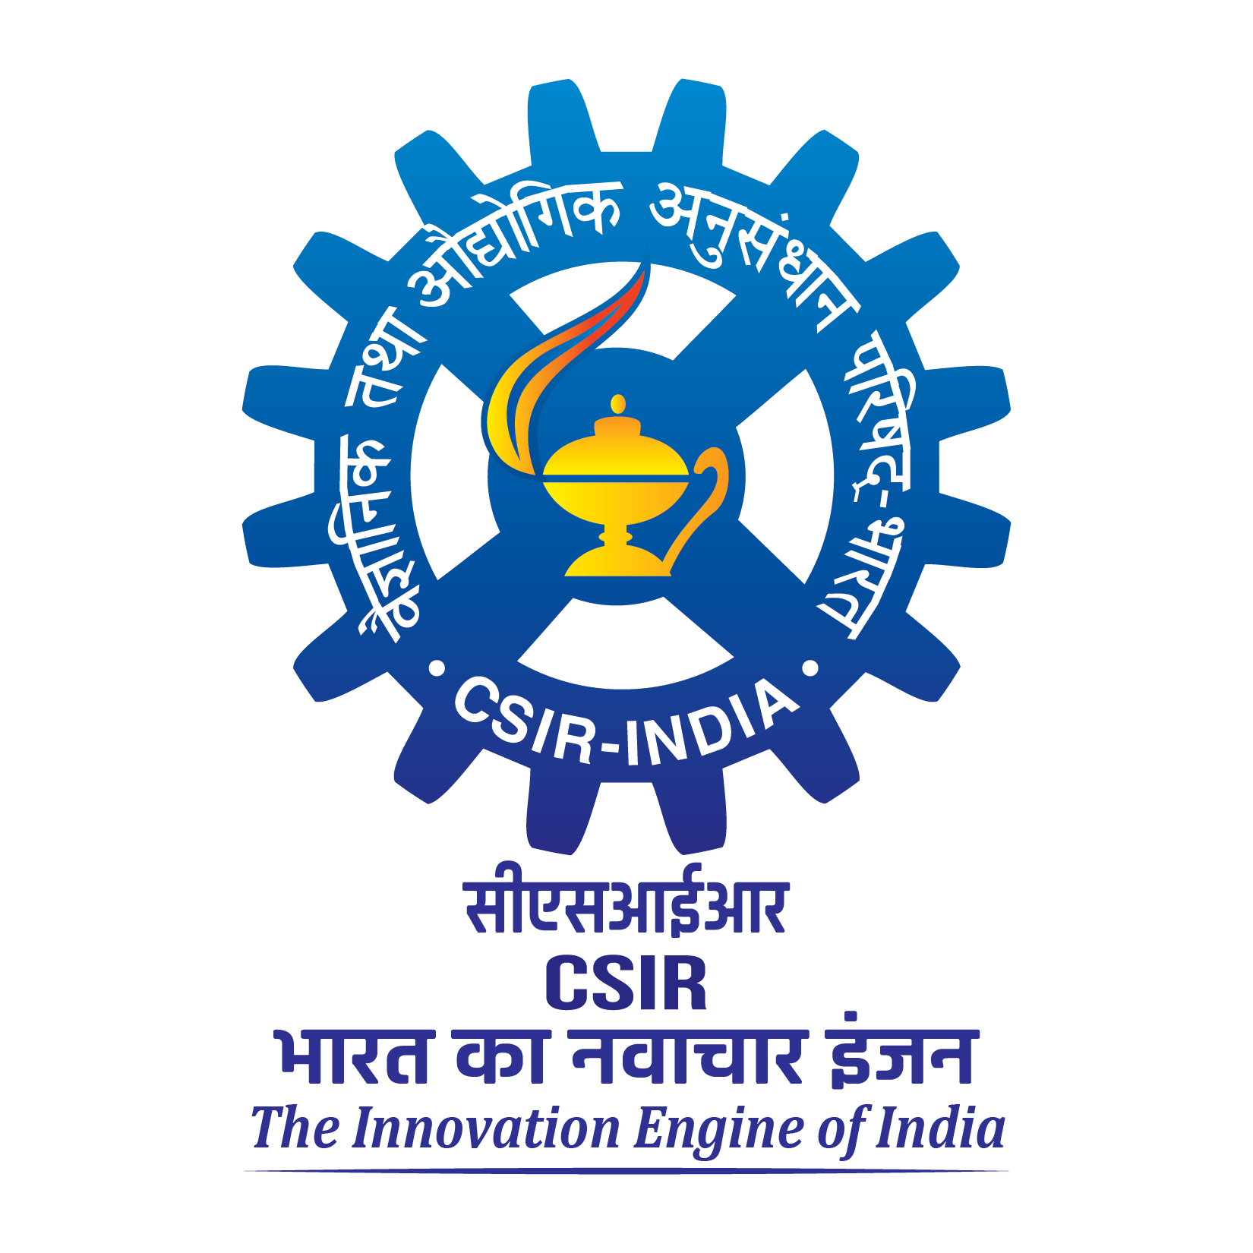 | CSIR-CENTRAL INSTITUTE OF MEDICINAL AND AROMATIC PLANTS  RESEARCH CENTRE, HYDERABAD-500092, TELANGANA.  Skill Development-cum-Training Program on  “Cultivation, Primary Processing, Quality and Marketing Aspects of Commercially Important Aromatic and Medicinal Crops”  (Under CSIR-Aroma Mission Phase III – HCP 0007) | 

Date: 12th – 14th November 2024 (3 days)

REGISTRATION FORM
- Name :

- Father/Husband’s Name :

- Date of Birth :

- Gender (Please √) : Male / Female / Transgender

- Educational Qualification(s) :

- Category (Please √) : Gen/ OBC/ SC/ ST

- Present Address :

- Phone/Mobile No. :

- E-mail :

- Aadhar No. :

- Profession (Please √) : Farmer/ Trader/ Entrepreneur/ Employee/ Student
- Name of organisation/ :
Individual & Address

- Description of land for :
Cultivation (Acre/ha)

- Crops cultivated at present, if any:

- Annual Income :
- Registration Fee Details : Payment Transaction No.
Date :

Place:
Date: SIGNATURE

Note: The bank transaction details of the registration fee along with the duly filled-in registration form enclosed with a copy of the Aadhar card should be sent to e-mail: crchyd@cimap.res.in on or before 08th November 2024, 5:00 PM and original documents should be submitted at the office on or before 12th November 2024 (Tuesday).

