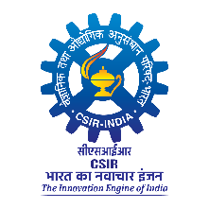 | CSIR - CENTRAL INSTITUTE OF MEDICINAL AND AROMATIC PLANTS  RESEARCH CENTRE, BENGALURU-560065  Skill-cum-Technology Up-gradation Programme on Cultivation and Primary Processing of Economically Important Medicinal and Aromatic Plants (Under Aroma Mission Phase-III) | 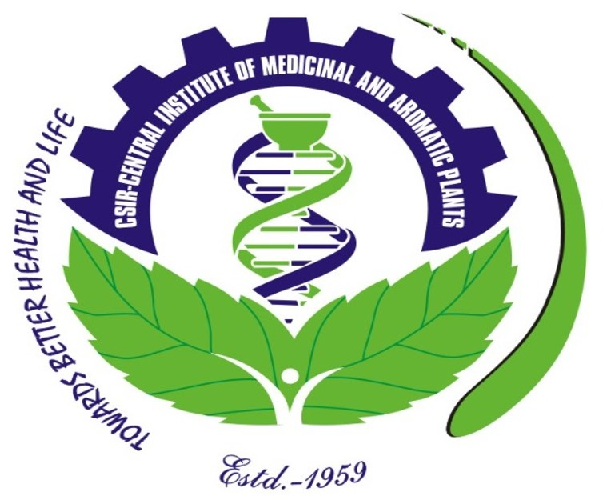

Venue : Ayya Nadar Janaki Ammal College, Sivakasi, Tamil Nadu

PHOTO

Date : 24 - 28 February, 2025

REGISTRATION FORM
- Name :

- Father’s Name :

- Date of Birth :

- Educational Qualification :

- Category : Gen/OBC/SC/ST

- Present Address :

- Phone/Mobile No. :

- E-mail :

- Aadhar No. :

- Name of organisation/ :
Individual & Address

- Description of land for :
Cultivation (Acre/ha)

- Annual Income :

- Other information, if any :
- Crops cultivated at present, if any :

- Details of online payment : Transaction No.
Date :

Place:
Date: SIGNATURE

Note: Please attach a valid Photo ID

